**Name - Pushpendra Dhakar(19229)**

**Roll number- 19229**

3. For the following loose pseudo-code implementation of a right-turning Bug 0 algorithm, draw a flowchart

(a) while not at goal location :

(b) move towards goal

(c) if hit an obstacle :

(d) while not able to move towards the goal :

(e) follow the obstacle moving to the right until can head toward the goal

**Sol**:

Flowchart for **Bug 0** Algorithm:

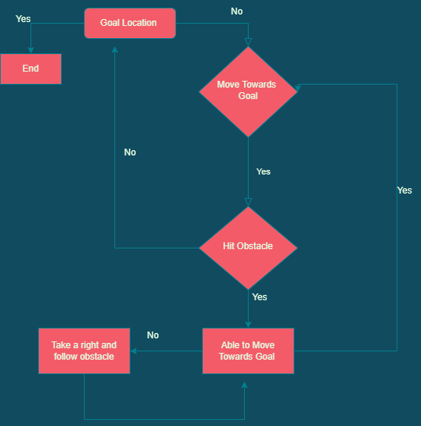

**Q4.Prove that Bug 0 is not a complete algorithm.**

**Sol:** Bug 0 Algorithm :

1. Go towards goal
2. Follow obstacle boundary

An algorithm is complete if, in finite time, it finds a path if such a path exists or terminates with failure if it does not.

The bug 0 algorithm is not a complete algorithm since it fails in specific scenarios.

It qhi be a point where it hits the algorithm(ith step)

qL: leaving point from an obstacle at ith step.

i=1

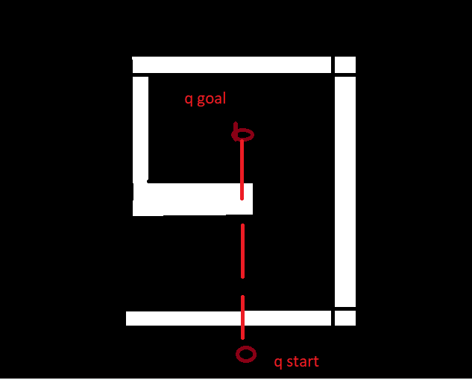

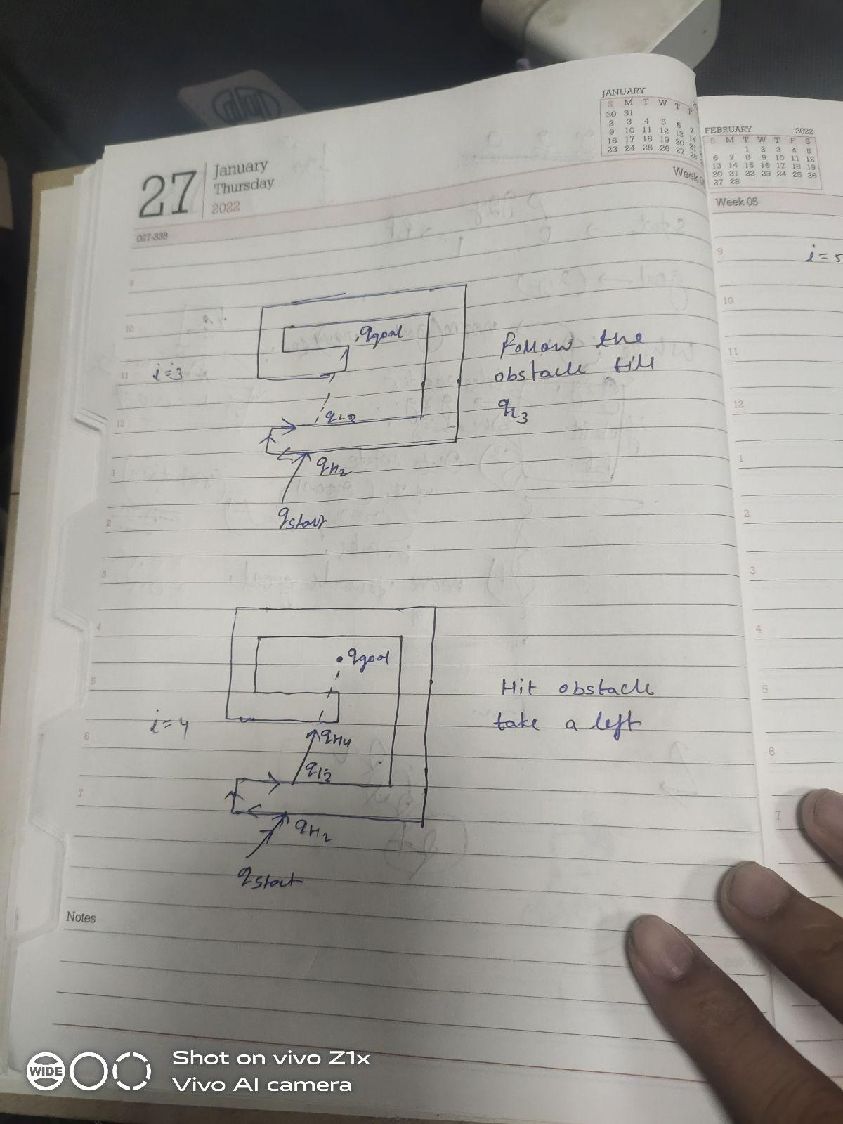

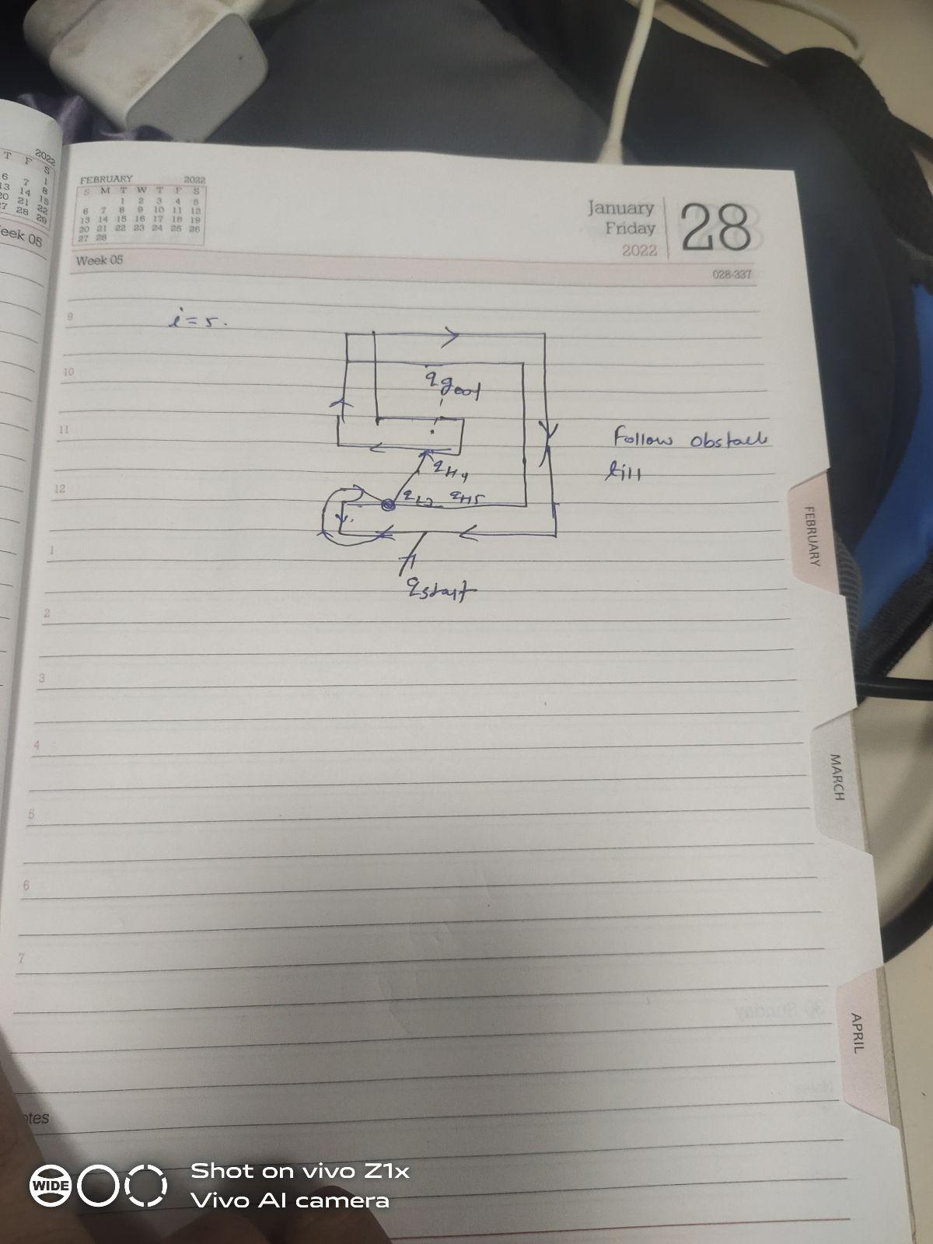

Now we can see that ql3 and ql5 are the same positions because er is in the same position. In two more steps, this cycle repeats and we reach the same point, resulting in a loop in which we never reach the goal. As a result, bug 0 is not a complete algorithm.

**Question 7:Use trapezoidal decomposition for the environment generated in the previous question and show the cells and also the Rebb graph.**

**Answer:**

1. A node corresponds to a cell.
2. An edge connects Nodes of adjacent cells.

Two cells are adjacent if they share a common boundary

Path Planning:

1. The planner selects cells that contain the start and end points.
2. The planner searches the adjacency graph for a path.

**Using Trapezoidal decomposition:**

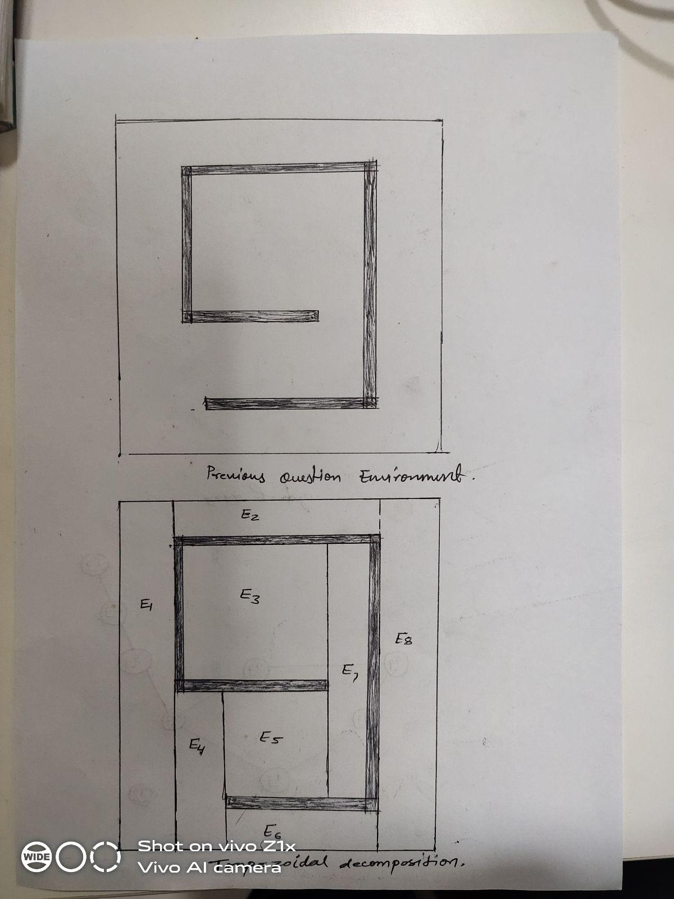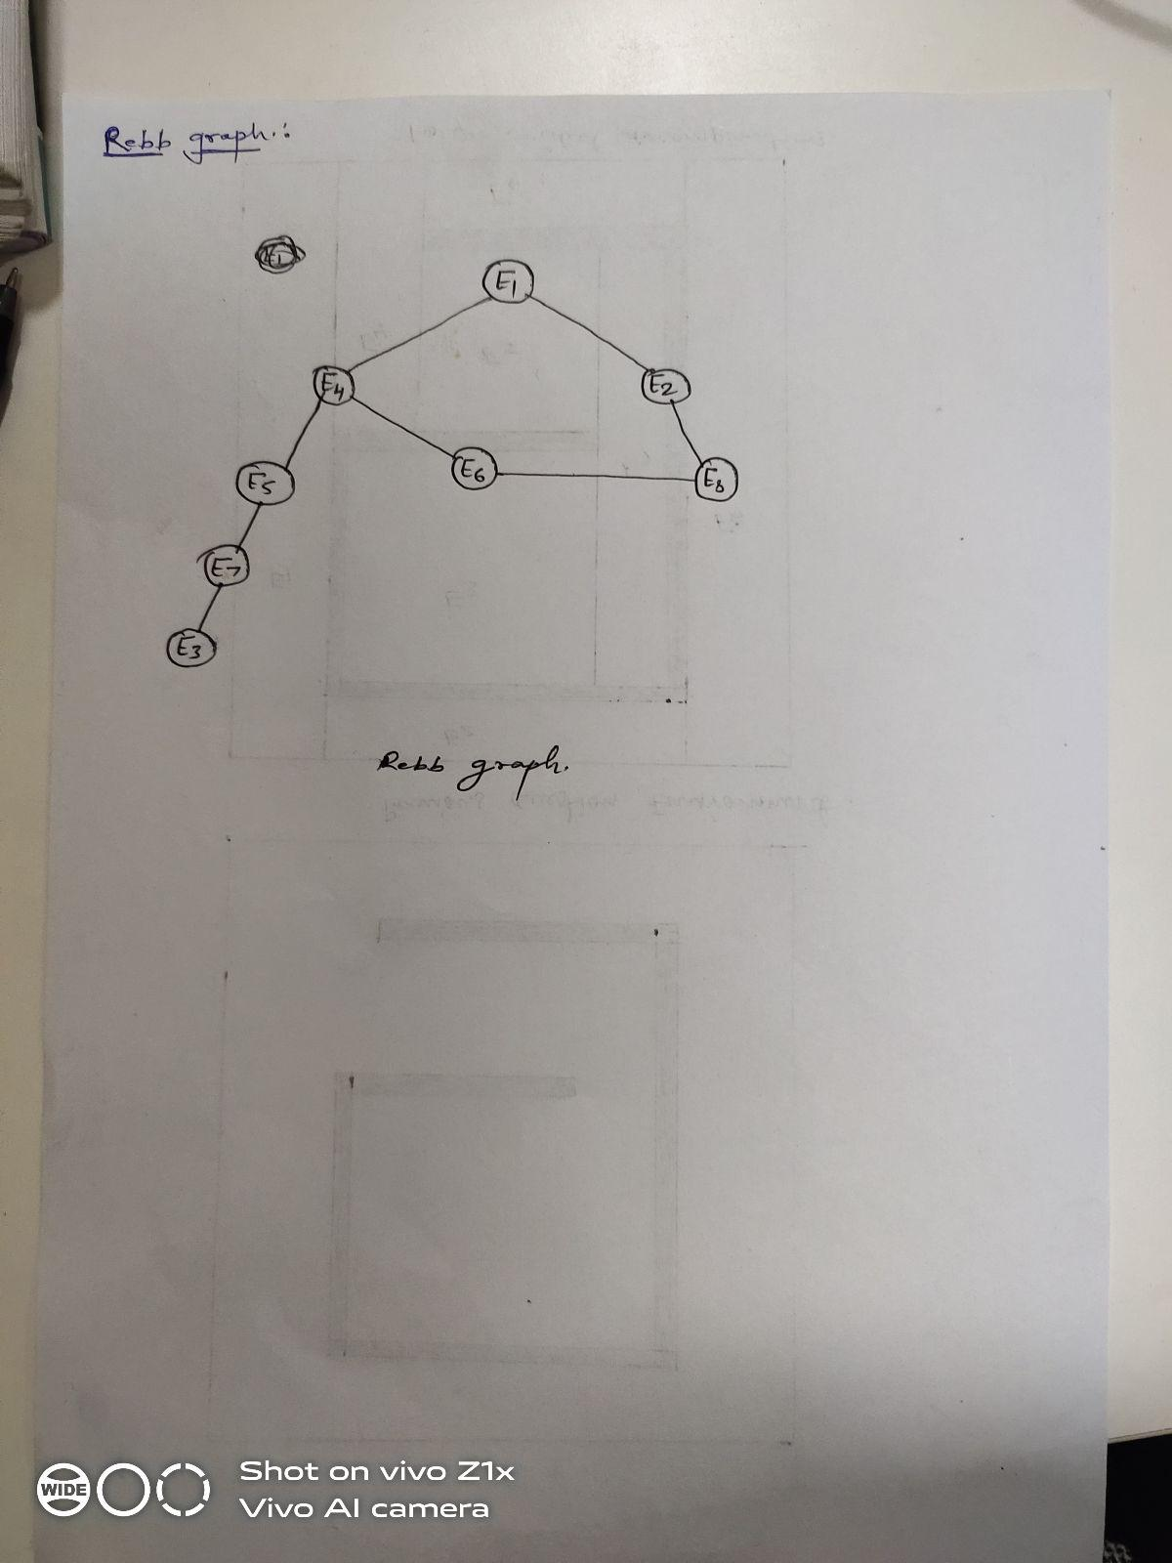

**Q6.Create an environment where Bug 2 (without memory) can be an incomplete algorithm and show through your implementation that it is incomplete. Explain why it is incomplete.**

**Sol:**

**Reason:** Even though the Bug2 algorithm is following the line(m- line) that we have drawn from the source to the destination(goal point), it is following a loop and coming back to the source point. The robot has a provision for crossing the line and finding its way to the other side of the line, but it always takes the left-hand direction to find the nearest point on the line, making the algorithm non-optimal.

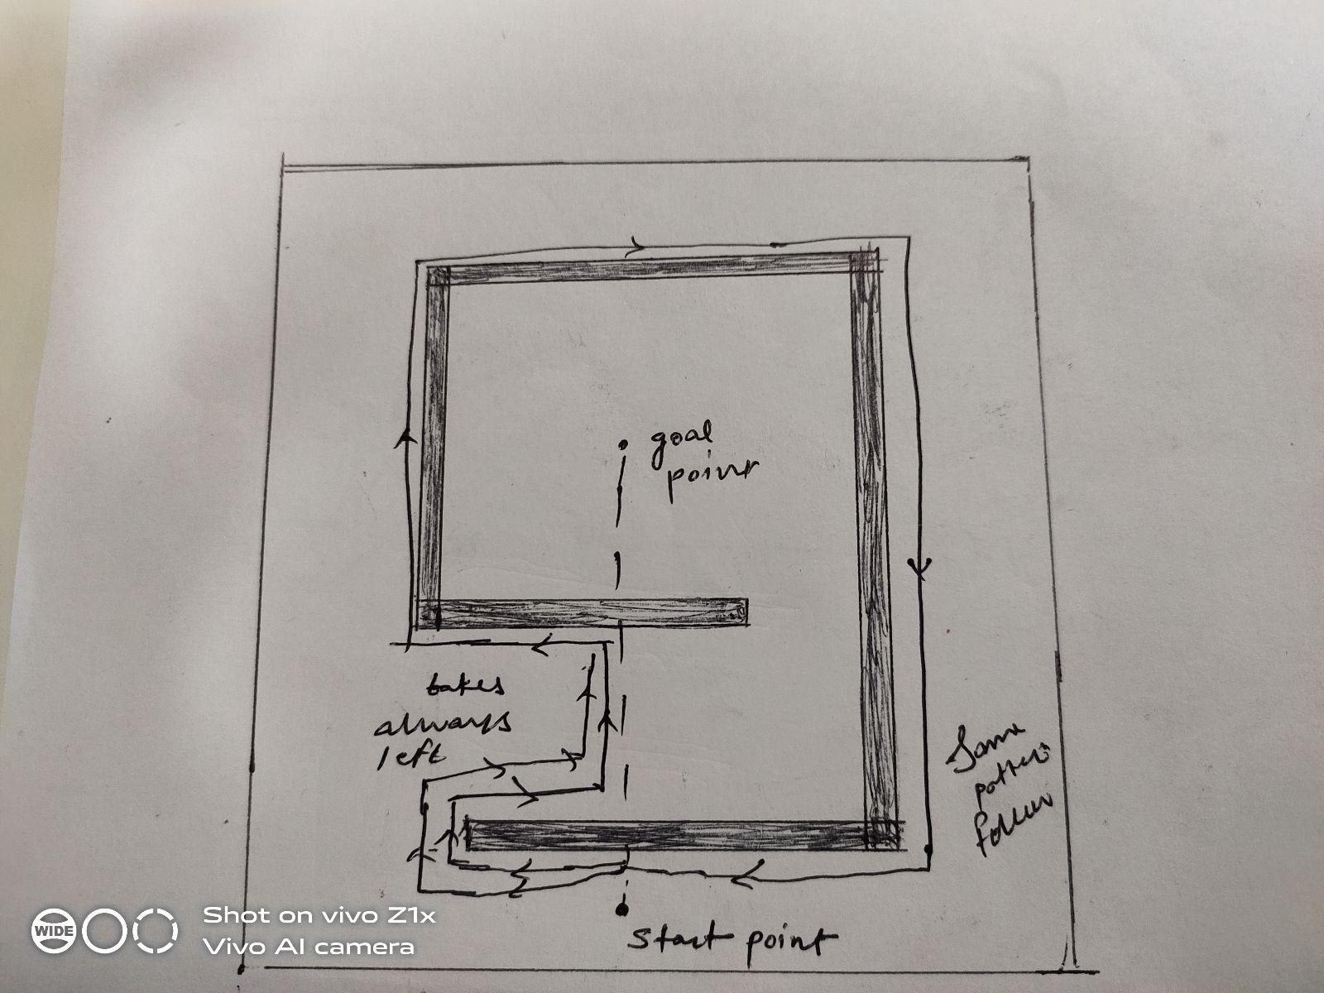

Contribution with SuryaPrasath Ramalingam (19315) and Vinita ,yusuf .